**Correlation of Demography in Indian Election**

**Introduction­**

Demography is a discipline that studies population-related phenomena, particularly in terms of size, composition, distribution, and population characteristics. Demography in elections of India explores the relationship between politics and population change with the Voter's turnout data and its Correlation with literacy rates, which also addresses concerns of gender-gap in society with literacy and the participation of females in the election. Different analyses to tell whether literacy is the parameter to judge turnout vote percentage. By Using Election Commission of India (ECI) data on Turnout-Vote % with the gender-wise division of Lok Sabha elections(General Elections) from 1962 - 2019, And by using Literacy rate and gender-wise distribution data by Census of India conducted by the [Registrar General and Census Commissioner of India](https://en.wikipedia.org/wiki/Registrar_General_and_Census_Commissioner_of_India) under the [Ministry of Home Affairs](https://en.wikipedia.org/wiki/Ministry_of_Home_Affairs_(India)), [Government of India](https://en.wikipedia.org/wiki/Government_of_India). In this project, I would like to analyze and discuss elections data in the context of the above-mentioned demographic parameters and predictions of elections voters data with respect to time for the near future.

**Proposed problem**

How can literacy data be used to judge the trend of Voters' turnout? What gender-wise Voters Turnout and Literacy Rate data tell about Gender-Gap in elections participation?

**Analysis**

The literacy rate increased from 1961 to 1991 from 28.3% for thirty years in 1961 to 52.2% in 1991. On the other hand, the vote figures stayed unchanged or fell further. When the crude literacy rate was 16.7 percent in 1951, the lowest since independence, the voting percentage was a respectable 61.2 percent in 1952.

The graph below shows the graph between Literacy rates by Census of India and general election voters turnout % by the Election Commission of India.

This graph shows that the steepness in the literacy rate line graph till 2009 does not bring any significant change in the Turnout-Vote line graph.

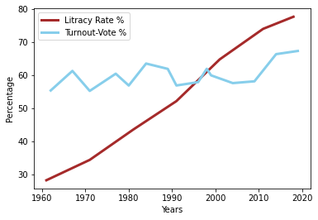

To show the Correlation between gender-wise turnout data, the line graph below shows gender-wise Turnout % with the total Turnout % from the data by ECI.

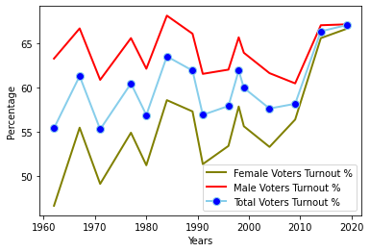

The graph clearly shows that the trend between Male and Female Turnout % was almost similar till 2004. Between 2004 to 2009, Female voters' turnout rises from 53.3% to 56.4%, whereas Male turnout decreases from 61.66% to 60.5%.

The graph below shows gender-wise data on turnout votes and literacy rates by calculating gender gap trends between genderwise records. This graph depicts the decreasing gender gap between males and females.

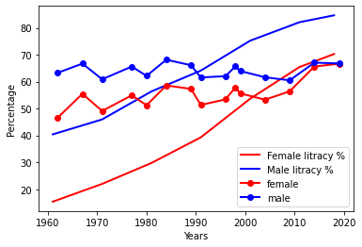

The graph shows that the decrease in the gap between male and female Literacy and increase in female literacy has subsequently decreased the gap between voters' turnout between males and females. This trend between reducing Gender-gap in turnout vote and literacy rate shown below shows how the change in literacy rate has subsequently affected the gender gap in turnout votes. Turnout gender-gap drops to just 0.4% in 2019, which is negligible considering the past gender-gap data.

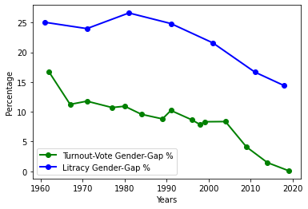

**Conclusion**

By analyzing the demography of elections, voters' turnout data with literacy rates gender-wise proves that the literacy rate increased rapidly. Still, the turnout voters' % remained unchanged for a very long period, indicating that an increase in literacy rate does not affect the turnout rate. Increasing literacy among females in recent times has improved their turnout rates rapidly. The graphs demonstrate that the decrease in the gap between the literacy rate of females and males with the increasing literacy rate of females rapidly had diminished the gender gap in voters' turnout records to just 0.4%.

**Source**

Graph Codes: <https://drive.google.com/file/d/1wes4XaF84Lzy4lHSUKwPykysQ_mBX6uE/view?usp=sharing>

<https://tcpd.ashoka.edu.in/lok-dhaba/>

<https://en.wikipedia.org/wiki/Literacy_in_India>

<https://geographyandyou.com/increasing-women-voter-turnout-in-indian-elections/>

<http://archive.indianexpress.com/news/voting-percentage-flies-in-the-face-of-literacy-rates/464862/>